SOFTWARE ARCHITECTURE DESIGN REPORT
Smart Museum Visitor Experience and Artifact Monitoring Platform

1. Analysis of System Requirements

1.1 Problem Recap and System Objectives
The Smart Museum Visitor Experience and Artifact Monitoring Platform must simultaneously (a) protect valuable, irreplaceable artifacts through continuous environmental and security monitoring, and (b) deliver an engaging, personalized, technology-driven visitor experience through AI recommendations and Augmented Reality (AR). The architecture must therefore support two operational profiles running concurrently: a latency-sensitive, high-frequency IoT data-ingestion pipeline, and a visitor-facing interactive application layer, both feeding a shared analytics and reporting capability.

1.2 Functional Drivers of Architecture
- Real-time ingestion and threshold evaluation of continuous IoT sensor streams (temperature, humidity, light, vibration, motion).
- AI-based personalized recommendation generation requiring access to visitor profile and behavioral data.
- On-demand AR content delivery triggered by artifact scans, requiring low-latency media retrieval.
- Independent security alerting and incident logging that must remain operational even if visitor-facing features are degraded.
- Visitor analytics and exhibition-layout optimization requiring batch/aggregate processing over large historical datasets.
- Ticketing/payment processing requiring secure, transactional integration with an external payment gateway.

1.3 Non-Functional Drivers (Quality Attributes)
Quality Attribute | Why It Matters for This System | Architectural Implication
Scalability | Visitor load spikes during peak hours/seasons; sensor count grows as museum expands exhibits. | Independently scalable services; horizontal scaling of visitor-facing services separate from monitoring services.
Performance | Environmental alerts must reach staff within seconds; AR content must render with minimal delay. | Asynchronous event streaming for sensor data; caching/CDN for AR media assets.
Reliability | Sensor data must not be lost even briefly, since gaps could hide a preservation risk. | Message broker with durable queues and edge buffering for offline resynchronization.
Availability | Security monitoring must remain available even during partial outages of other modules. | Loosely coupled services so failure in one (e.g., AR service) does not bring down monitoring.
Security | Visitor PII, payment data, and artifact security data require strong protection. | API Gateway with centralized authentication/authorization; encryption in transit and at rest; RBAC.
Maintainability | Museum technology partners (AR/AI vendors) may change over the system's lifetime. | Modular, well-defined service boundaries and interfaces (APIs) that isolate change.
Note: the table above intentionally treats every module as independently replaceable, which is the central argument used in Section 2 to justify the selected architectural style.

2. Selection of Suitable Software Architecture

2.1 Candidate Styles Considered
Architectural Style | Suitability for This System
Layered (Monolithic) Architecture | Simple to build initially, but tightly couples IoT monitoring, AR delivery, and analytics — a bug or scaling need in one module risks affecting all others. Poor fit given divergent load/latency profiles.
Pure Client-Server | Adequate for basic request/response but does not naturally support the continuous, high-frequency, asynchronous sensor data streams the system requires.
Model-View-Controller (MVC) | Useful within an individual client application (e.g., the dashboard UI) but does not address backend scaling, service isolation, or IoT stream processing on its own.
Pure Serverless (FaaS only) | Good for bursty, stateless tasks (e.g., report generation) but less suited to persistent, stateful IoT stream processing and long-lived AR sessions.
Microservices Architecture | Enables independent scaling, deployment, and technology choice per capability (monitoring, AI, AR, ticketing) — matches the system's divergent quality-attribute needs well.
Event-Driven Architecture (EDA) | Ideal for the continuous, asynchronous IoT sensor streams and alerting, decoupling producers (sensors) from consumers (alert engine, analytics).

2.2 Selected Architecture: Hybrid Microservices + Event-Driven Architecture (with API Gateway and Layered Client)
The recommended architecture is a hybrid style combining Microservices Architecture for the application layer with Event-Driven Architecture for IoT/sensor communication, fronted by an API Gateway, and using a conventional layered structure (Presentation to Gateway to Services to Data) for overall organization. This hybrid is deliberately chosen rather than any single "pure" style because the problem statement itself combines two distinct workloads — synchronous, visitor-facing interactions and continuous, asynchronous IoT telemetry — that are best served by different communication patterns within one coherent system.

2.3 Justification
- Divergent scaling needs: Visitor-facing services (AI recommendations, AR content, ticketing) must scale with visitor footfall, while monitoring services must scale with sensor count — microservices allow each to scale independently.
- Continuous IoT streams: Sensor data arrives continuously and asynchronously; an event bus (MQTT for edge ingestion, Kafka for internal streaming) decouples sensors from consuming services and prevents data loss during downstream slowdowns.
- Fault isolation: Because artifact security and preservation are mission-critical, the architecture must ensure a failure in a non-critical service (e.g., AR rendering) cannot disable artifact monitoring or security alerting — a monolith cannot guarantee this, but independently deployed microservices can.
- Independent technology evolution: AI recommendation models and AR rendering SDKs evolve rapidly and are often supplied by third parties; isolating them as separate services allows upgrades without touching monitoring or ticketing code.
- Centralized security and simplicity for clients: An API Gateway gives visitor apps, dashboards, and admin consoles one unified, authenticated entry point, hiding internal service complexity and enabling consistent rate limiting and TLS termination.

3. Software Architecture Diagram
The diagram below illustrates the layered organization of the hybrid Microservices + Event-Driven architecture, including client applications, the API Gateway, the microservices layer, the asynchronous event bus, the polyglot data layer, and external/IoT systems.

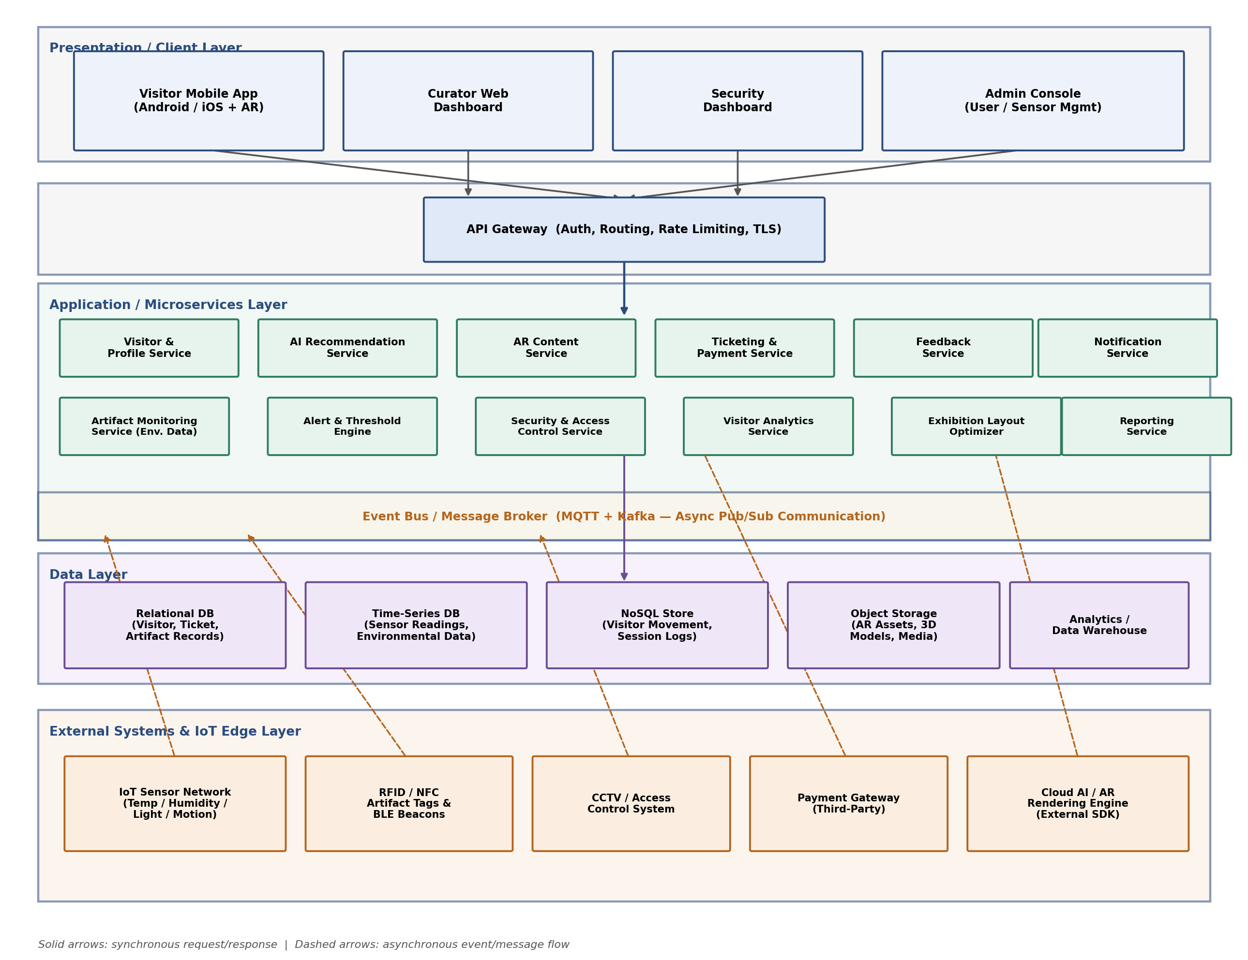
Figure 1: Proposed Software Architecture — Smart Museum Platform (Hybrid Microservices + Event-Driven)

4. Components and Their Interactions

4.1 Presentation / Client Layer
- Visitor Mobile App — hosts AR rendering, tour recommendations, ticketing, and feedback UI; communicates with backend only via the API Gateway over HTTPS.
- Curator Web Dashboard — used by curatorial staff to view artifact condition data, manage exhibits, and view analytics.
- Security Dashboard — real-time view of security alerts, incident logs, and CCTV correlation.
- Admin Console — user, sensor, and system configuration management.

4.2 API Gateway
The API Gateway is the single entry point for all client requests. It performs authentication/authorization (issuing and validating tokens), request routing to the correct microservice, rate limiting to protect backend services from overload, and TLS termination. This centralizes cross-cutting security concerns rather than duplicating them in every service.

4.3 Microservices (Application Layer)
Service | Responsibility
Visitor & Profile Service | Manages registration, authentication data, preferences, and visit history.
AI Recommendation Service | Generates personalized tour itineraries using visitor profile and behavioral data.
AR Content Service | Serves AR assets (3D models, narration) triggered by artifact scans.
Ticketing & Payment Service | Handles ticket booking and communicates with the external Payment Gateway.
Feedback Service | Collects and stores visitor ratings and comments.
Notification Service | Sends push notifications/alerts to visitors and staff.
Artifact Monitoring Service | Consumes IoT sensor events and records environmental readings.
Alert & Threshold Engine | Evaluates readings against thresholds and raises alerts.
Security & Access Control Service | Processes RFID/motion events for unauthorized movement and access breaches.
Visitor Analytics Service | Aggregates anonymized movement/dwell-time data for behavior analysis.
Exhibition Layout Optimizer | Produces layout recommendations from analytics output.
Reporting Service | Compiles periodic performance and preservation reports.

4.4 Event Bus / Message Broker
MQTT is used at the IoT edge for lightweight, low-power sensor-to-cloud transmission, while Kafka provides durable, ordered, high-throughput internal event streaming between services. Producers (sensors, RFID readers, the mobile app) publish events without needing to know which services will consume them; the Alert & Threshold Engine, Artifact Monitoring Service, and Visitor Analytics Service subscribe independently. This publish/subscribe pattern decouples producers from consumers and allows new analytics consumers to be added without modifying existing producers.

4.5 Data Layer
- Relational Database — structured, transactional data: visitor accounts, tickets, artifact master records.
- Time-Series Database — high-volume, timestamped sensor readings optimized for range queries and trend analysis.
- NoSQL Store — semi-structured visitor movement/session logs with flexible schema and high write throughput.
- Object Storage — large binary AR assets (3D models, audio, video).
- Analytics/Data Warehouse — aggregated data for reporting and exhibition-layout optimization.
Each microservice owns its relevant data store(s) rather than sharing a single monolithic database, consistent with the microservices principle of decentralized data management; this avoids tight coupling between services at the data level.

4.6 External Systems and IoT Edge Layer
- IoT Sensor Network — publishes continuous environmental readings via MQTT.
- RFID/NFC Tags and BLE Beacons — identify artifacts and support indoor visitor positioning.
- CCTV/Access Control System — integrated for security correlation, not replaced by this platform.
- Payment Gateway — external, PCI-DSS-compliant third-party service invoked synchronously by the Ticketing Service.
- Cloud AI/AR Rendering Engine — external SDK/service supplying AI inference and AR rendering capability.

4.7 Overall Workflow Example
Example 1 — Environmental Alert: An IoT sensor publishes a temperature reading over MQTT, the event is placed on the Kafka event bus, the Artifact Monitoring Service persists the reading to the Time-Series DB while the Alert & Threshold Engine simultaneously evaluates it, and if a threshold is breached, an alert event is published and the Notification Service delivers it to the Curator/Security Dashboard in near real time.
Example 2 — Personalized Visit: A visitor logs in through the mobile app, the request passes through the API Gateway to the Visitor & Profile Service, the AI Recommendation Service retrieves profile and historical data to generate an itinerary, and as the visitor scans an artifact tag, the AR Content Service (via the Gateway) retrieves the relevant 3D asset from Object Storage and streams it to the app; the visit is later reflected in the Visitor Analytics Service via published movement events.

5. Discussion of Quality Attributes

5.1 Scalability
Because each capability is a separately deployable microservice, services experiencing high demand (e.g., AI Recommendation Service during peak visiting hours, or Artifact Monitoring Service as sensor count grows) can be scaled horizontally — adding more instances — independently of lower-demand services such as the Admin Console backend. The event bus further absorbs bursts of sensor traffic without overwhelming downstream consumers.

5.2 Security
Security is addressed at multiple layers: the API Gateway centralizes authentication, authorization, and TLS termination; role-based access control (RBAC) restricts each actor to permitted operations; sensitive data (visitor PII, payment details) is encrypted in transit and at rest; and the Payment Service isolates payment-card handling from the rest of the system, reducing PCI-DSS compliance scope.

5.3 Performance
Latency-sensitive paths are optimized directly: environmental alerts flow through the low-overhead event bus rather than a synchronous chain of service calls, and AR media is served from Object Storage (optionally behind a CDN) to minimize retrieval delay. Non-urgent, compute-heavy work such as exhibition-layout optimization is decoupled into asynchronous/batch processing so it does not block interactive requests.

5.4 Reliability
Kafka's durable, replicated log ensures sensor events are not lost even if a consuming service is temporarily unavailable; edge devices buffer readings locally during network outages and resynchronize on reconnection (per NFR-05 of the SRS). Each microservice can also implement retries and circuit breakers when calling external systems such as the Payment Gateway.

5.5 Maintainability
Clear service boundaries mean a change to, for example, the AR rendering integration only requires redeploying the AR Content Service, not the entire system. Each service can be developed, tested, and released independently by different teams, and the well-defined API Gateway contract shields client applications from internal refactoring.

5.6 Availability
Loose coupling ensures that the failure of a non-critical service (e.g., Feedback Service) does not cascade into mission-critical services (Artifact Monitoring, Alert & Threshold Engine, Security & Access Control). Redundant service instances behind the Gateway, combined with the durable event bus, support the 99.5% availability target for core monitoring services specified in the requirements.

6. Justification of Architectural Decisions and Trade-offs

6.1 Rationale Summary
The hybrid Microservices + Event-Driven architecture was chosen because no single "pure" style adequately serves both the continuous, safety-critical IoT monitoring workload and the interactive, visitor-facing application workload. Microservices provide the isolation and independent scalability needed given the system's varied components (AI, AR, IoT, ticketing, analytics), while the event-driven backbone specifically matches the asynchronous, high-frequency nature of sensor data and alerting.

6.2 Trade-offs Considered
Trade-off | Discussion
Operational complexity vs. isolation | Microservices introduce deployment, monitoring, and inter-service communication overhead compared to a monolith. This is accepted because the isolation benefit (a failure in AR delivery cannot disable artifact security monitoring) is critical for a system protecting valuable, irreplaceable artifacts.
Eventual consistency vs. simplicity | Event-driven communication means some data (e.g., analytics dashboards) reflects a brief delay rather than being instantly consistent. This is acceptable for analytics/reporting use cases but not for payment transactions, which is why the Ticketing Service uses a synchronous call to the Payment Gateway instead of an asynchronous event.
Polyglot data stores vs. single database | Using different databases per data type (relational, time-series, NoSQL, object storage) adds operational overhead versus one shared database, but greatly improves performance and scalability for each distinct access pattern; this is a standard microservices "database-per-service" trade-off deliberately accepted here.
Third-party dependency vs. build in-house | Relying on external AI/AR SDKs and a payment gateway reduces development time and cost, at the expense of vendor lock-in risk; this is mitigated by isolating each dependency behind its own microservice interface.

6.3 Support for Future Enhancements and Long-Term Maintainability
- New capabilities (e.g., a new AI model, a new sensor type, a loyalty/rewards service) can be added as new microservices and new event topics without redesigning the existing system.
- The API Gateway allows new client applications (e.g., a future smart-kiosk interface) to be added without changes to backend services.
- The event-driven backbone allows the museum to add new analytics consumers (e.g., a future predictive-maintenance model for HVAC systems) simply by subscribing to existing sensor event streams.
- Because each service owns its data and interface, the architecture supports phased modernization — for example, migrating the Analytics/Data Warehouse to a new platform without impacting the Visitor & Profile Service.
- Standardized, versioned APIs at the Gateway support long-term integration with additional third-party heritage/museum information systems (e.g., national museum databases).

6.4 Conclusion
The selected hybrid Microservices and Event-Driven Architecture, fronted by an API Gateway and backed by a polyglot data layer, directly addresses the dual nature of the problem statement — safety-critical, continuous artifact monitoring alongside rich, interactive visitor engagement — while satisfying the scalability, security, performance, reliability, maintainability, and availability requirements identified in the requirement analysis. The architecture is deliberately structured to accommodate future growth in sensor count, visitor load, and feature scope with minimal disruption to existing components.

